**CAPACITOR**

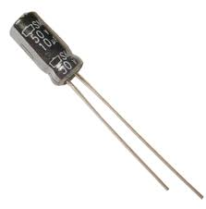

Capacitor is a passive component used to store charge. The charge (q) stored in a capacitor is the product of its capacitance (C) value and the voltage (V) applied to it. Capacitors offer infinite reactance to zero frequency so they are used for blocking DC components or bypassing the AC signals. The capacitor undergoes through a recursive cycle of charging and discharging in AC circuits where the voltage and current across it depends on the RC time constant. For this reason, capacitors are used for smoothing power supply variations. Other uses include, coupling the various stages of audio system, tuning in radio circuits etc. These are used to store energy like in a camera flash.

Capacitors may be non-polarized/polarized and fixed/variable. Electrolytic capacitors are polarized while ceramic and paper capacitors are examples of non polarized capacitors. Since capacitors store charge, they must be carefully discharged before troubleshooting the circuits. The maximum voltage rating of the capacitors used must always be greater than the supply voltage.

**Pin Diagram:**

